

Design and develop a website

By Arnas Trainis



April 25, 2022

NCC London

[Company address]

Plan

This website will be created following the client’s requirements and what they want to do, below is explained exactly what I will be doing to create this website and what I will be following.

I will be designing and making a website based off of what the client wants to be included. First, I will be creating a design for the website which should take a few days and then I will be reviewing it with the client to see if it is good and then improving upon it. Afterwards I will create 3 different home page designs and have a few people review it and choose the one they like the most. This will then allow me to find the best design and I will then create the rest of the pages in that design. This will be made in HTML, and I will also show screen shots of what I have done in HTML.

Before making the website, I will be making a storyboard of what will be included and how the website will be built to have something to show to the client and also to have an idea of what will be exactly included. I will also ned to make sure that all features of the website work as intended and test them all. I will then be reviewing my website and how well it meets the client’s requirements, next I will justify all the decisions I have made throughout the plan and how I designed and made the website. I will then optimise the website to meet the client’s requirements as intended and lastly, I will evaluate the design and the optimisation of the website to the client’s requirements and see if it is made exactly how the client wants.

Below is the timescale I have made for when I should be doing things at certain parts of the assignment and when I should be done with them. This is a plan I will try to follow and make sure to get things done by the allocated times.

Task Start date End date Followed y/n

|  |  |  |  |
| --- | --- | --- | --- |
| Produce designs | 25/04/2022 | 26/04/2022 | n |
| Review website designs | 27/04/2022 | 27/04/2022 | n |
| Produce a website | 27/04/2022 | 30/04/2022 |  |
| Test website out | 1/05/2022 | 1/05/2022 |  |
| Review extent to which website meets client requirements | 2/05/2022 | 3/05/2022 |  |
| Justify decisions made | 4/05/2022 | 5/05/2022 |  |
| Optimise the website | 6/05/2022 | 8/05/2022 |  |
| Evaluation of everything | 9/05/2022 | 11/05/2022 |  |

Review website design with others to identify and inform improvements

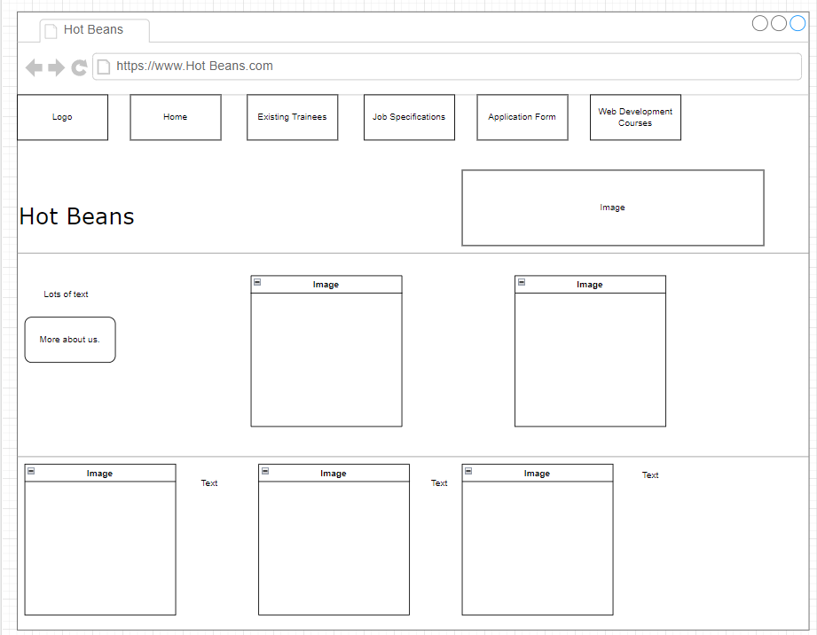

A

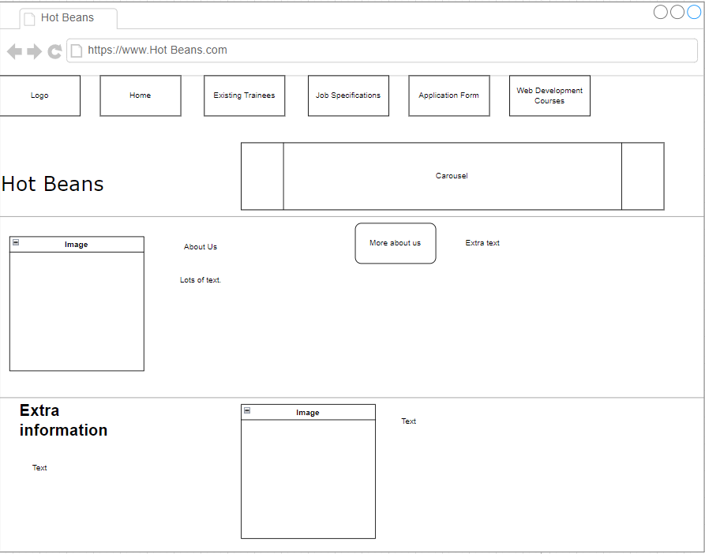

B

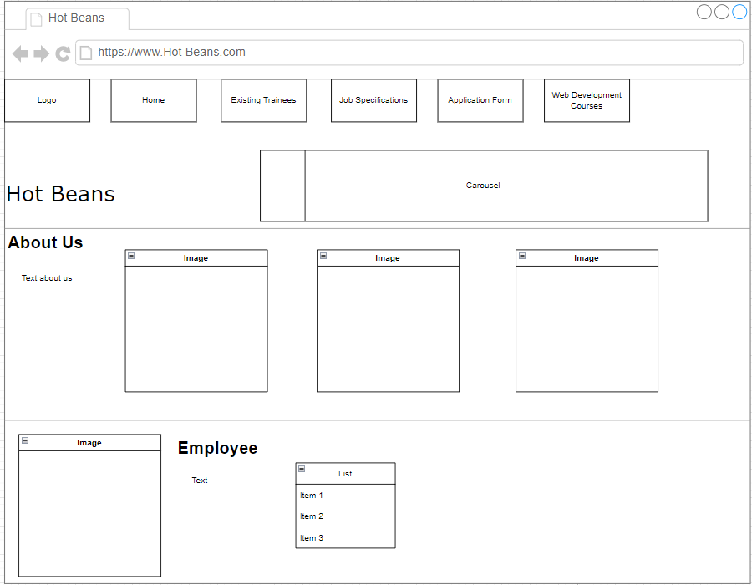

C

The one with the most likes is the first one.

Abdurrahman Ahmed:

He chose the first one out of the three designs and said it was the best out of the three designs presented. He said that the placements of the images and the text were really good and would allow for good interaction with anyone visiting and viewing the website.

The other home page designs I was told were not as good because of the placements of both text and images and it is seeming really out of place and not as well thought out as the first one.

Orestas Vecys:

He chose the third home page design and said that the layout was a lot nicer compared to the first and second one. He said that the third one has a nice design and page layout which looks cohesive and a lot better to understand for anyone visiting the page.

He said that the other two were not as good because they seemed really blocky and not as good as the layout and design of the third home page and lacks the readability and the simplicity of the third page.

Joshua Rios:

He chose the second one out of the three home page designs. He said that the page breaks and the white spacing was good for the website as well as the placement of the texts and images which makes the website look appealing and easy to navigate. He said that this was what made this home page design the best.

He said that the other two were not that bad but were just not as good as the second one and that they are not as well laid out and planned out with not enough white spacing for the page to look nice.

Me:

Since all 3 have each gotten one pick for the best so it is up to me to choose the design I want to go with. I think that the second design is the best because of the simplicity and also the white spacing used, on top of that the placement of the few images included and where the text is placed.

Above are the plans for the other web pages and will use.

Testing Website

The website can be used on mobile as well as just on pc as can be seen that when the page is made small there are still ways to access the other web pages and you can also scroll down and see what else is on the page.



The links to the other web pages work and take you to the page that it needs to, this is the case on every page and each works as intended. The logo also works on every page and works similarly to the home link, if pressed it will take you to the home page from any page.

This text on the bottom of this card you can press on and will work to take you to the Existing trainees and employees web page as it is a working link. This another way for you to go and access that web page instead of using the navbar.

These are links on the external course’s web page and the codecademy link does not work.

This is what shows up when you press on the link. We can see that the issue is that there is a letter missing in the link and I will go ahead and fix that mistake so as that when the link is pressed on it will actually take you to the website.

Here we can see the html that has been fixed to allow for the page to work and now once pressed on it will actually take you to the page that you want to go to. Everything else on the website works as intended and as a whole the rest of the website is functional, compatible and usable.

Review the extent that the website meets client requirements

To an extent the website meets client requirements by having everything that is required of it from the text that is informative to the courses and applications web page. The website has been reviewed by the client and the client has said that there can be an improvement with certain web pages to make them more interactive and responsive as well as usable. One example given has been about the application web page.

Here we can see where it says ‘Apply!’ is what could be improved to meet client requirements as that does not allow you to press on it and does not allow you to submit the application form. This is one thing that does not meet the client requirements and will need to be fixed in order to meet the requirements.

This part of the website meets client requirements as the client has said that it has all the information necessary for the home page and is informative enough as well as intriguing and eye catching when you first enter the page. However, I was told that the little bit of text above could either be removed or improved upon to make the page look a lot nicer and meet the client’s requirements.

The job specifications page the client has said that it is good enough and is more than enough for that web page and further text and or anything else is not necessary to add to it. This means that this whole web page is fine, and it all meets the client’s requirements of what the job specification page should look like.

The client has also said that the employees and trainees web page also meet the requirements and is yet again another good page that fits all that it needs to. I was told that the placement of the cards and the text is all adequate and does not need to be changed and or improved in the future design of the website.

Overall, the website mostly meets the client’s requirements except for a few things that can be changed or improved upon to meet the requirements. These things will be looked at and dealt with accordingly for the whole website to then meet the client’s requirements.

Justifying design decisions and how they will meet user’s needs and be fit for purpose

I have chosen to design the page like this because it allows for the user to see everything very clearly and also allows for the user to get to the point of the web page. This is done so the user is able to see exactly what the pages’ purpose is and what it has to say. Not only does it meet the user’s needs but is also fit for purpose as it does what is needed of it by giving a quick rundown of the websites purpose and what is Hot Beans.

This part of the web page was designed in such a way to give some extra information about Hot Beans and was also another way to allow for the user to go ahead and go to the trainees and employees web page. This will meet the user’s needs as it allows for them to see a quick rundown of what else is to do with the company and as said before gives them the option to go to a different web page. This is also fit for purpose as it allows for the website to seamlessly flow from one page to another.

This web page was designed in this way to feel somewhat spacious when viewing but also, so it is easier to distinguish every card from each other. It also seems nice to the eye because of the spacing and the number of cards used. This meets the user’s needs as they are able to clearly see the roles of the people and what they do, which is useful as it gets straight to the point.

This has been designed in such a way because it was meant to look very simple and basic so as to be super easy to understand and read. This then allows for anyone viewing it to instantly be able to read through it quickly and understand what it is saying and to understand it. This meets the user’s needs as they are not confronted with too much clutter and useless information but immediately are told what is required. Making it a lot easier for the user to understand the web page and to be able to move on faster. This is fit for purpose for the page as the whole point of it is to immediately tell you what is needed to apply.

The application form has been made this way to allow for people to easily see what they need to do and what it is they need to input. It is made really simple to use and also allows for you to upload your own files. This then meets the user’s needs because it allows for them to easily apply to Hot Beans without a hassle. Also, is fit for purpose as it does what is needed of it with no problem.

This page was designed in a way to easily view and access other websites without anything cluttering the screen and making it hard to understand the purpose of the web page. This then meets the user’s needs as it immediately gives them what they want and gives access to the other websites and courses. Finally, it is fit for purpose as it does what is needed of the page by giving access to the other websites.

Optimising a website to meet client requirements

As can be seen there has been an alert added to the homepage as well as extra text on the about us to optimise the webpage and meet client requirements as now the homepage is less boring and has extra information on it now. Which makes the homepage optimised and better over what it previously was with the slight changes applied.

Here we can see the application form and the now new button which takes you to another page. This has been optimised to meet the client’s requirements as there used to be just text there that did nothing, but now there is a button which actually works.

This is where you are taken to after pressing the ‘Apply!’ button which is this page. This optimisation has been made to ensure that the website is more interesting and interactable which is what the client wanted. An alert has been added to this page as well as a button which takes you to the homepage so that you can continue going through and checking out the website.

Annotating webpages

At the top of the page is the navbar and the logo. Below that is a heading and an alert, underneath that is a carousel. Continuing on there is text and underneath that is 3 cards with an image and text. On the last half of the page is a card and a list.

On the second webpage we have a navbar and a logo and under that we have four cards with an image and text.

On the third webpage we have a navbar and a logo and underneath that is a container with text.

The fourth webpage has a navbar a logo and underneath that a heading and an application form with a button.

On the last webpage we have a navbar a logo and underneath that four cards with an image and text which also have links connected to them, to the right of those we have a container with text.

Evaluate the design and optimised website against client requirements

Not much of the design has changed too much, the website is practically the same with only the differences being some alerts and buttons added to the website which now makes the website a lot better and now meets the client’s requirements as only a few things needed to be changed and or improved upon. This included the button being added in the application page, the alerts and also the extra text on the homepage.

The plan created for the website was similar to the actual website in terms of how it met the client’s requirements and what was missing, they were practically the same and for the most part everything met the client’s requirements. Anything that was not met was then fixed in the optimisation of the website leading the website to be fully optimised and allowing for it to meet the client’s requirements.

The actual website itself now meets all of the client’s requirements that were discussed as anything that was previously missing from the website is now included and what required changing has now been changed. So, this means that the design of the website and optimisation of it has allowed for all aspects of the client’s requirements to be met overtime.

A disadvantage of the website is that there is not a lot of text which sometimes makes some of the webpages seem boring or empty and makes others seem lacking. Another disadvantage is that spacing is not always used effectively in all the webpages and some seem a lot more cluttered and closer together which can be seen as a problem sometimes.

An advantage of the website is the features that have been added onto it such as the alerts and the carousel which make it more interactable and more fun and interesting to browse. Also, the use of the application form and how the spacing was used there and the features applied into the webpage.

Overall, the website is good because it meets the client’s requirements and has everything that is needed of it in all of the webpages. It meets user needs as well by doing what it has to and also is fit for purpose as everything works on the webpages as intended. So with all of this taken into consideration this makes the website as a whole very good and as said is effective at what it does and meets every requirement that it needs to.